**Full Name: ____________________________**

**Class Exercise Challenge #2**

**GAME 2343/2347 and IMED 1345/2345**

After today’s lecture and hands on activities, you will need to complete the following challenge:

1. Create two new variables, create the first variable another game name variable type string, second variable, provide the number of stars the game receives. Provide the sentence, “The (the new game variable goes here) provide the amount of stars receives.”

Here’s a screen shot of the output I would like for you to hard code.

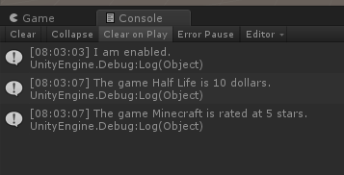

2. Toggle between the two states (checked and unchecked), you will need to take the screen shot, copy and paste it below.

3. Upload this document to eCampus before the due date.